Instagram Content Planning Document

Title Page
Account Name: smoothiebarinfusions
Date Created: 12/09/2025

Title | Post Date | Time | Link | Notes | Hashtags | Type
WIB | 12/13 | 11:00am |  | SL x PJ | #WillItBlend #SmoothieBar #DualTank #CannabisBlends #LAcannabis #StrainPairing #FlavorSpotlight | Post
The Student | 12/14 | 9:00am |  | Media exists | #smoothiebar #blend2 #whatsyourblend | Reel
Pier #2 | 12/15 | 10:00am |  | Lifestyle | #blend #smoothiebar #blend2 #whatsyourblend #santamonicapier | Post
SmoothiEdu | 12/16 | 1:00pm |  | Genetics | #Smoothiebar #blend2 #CannabisEducation #whatsyourblend | Post
WIB | 12/17 | 12:00pm |  | CL x ZU | #WillItBlend | Post
The Baller | 12/18 | 9:00am |  | Media exists | #smoothiebar #blend2 #whatsyourblend | Reel
Pier #3 | 12/19 | 11:00am |  | Lifestyle | #blend #smoothiebar #blend2 #whatsyourblend #santamonicapier | Post
SmoothiEdu | 12/20 | 5:00pm |  | Topic TBD | #Smoothiebar #blend2 #CannabisEducation #whatsyourblend | Post
WIB | 12/21 | 10:00am |  | Blend TBD | #WillItBlend | Post
Render | 12/22 | 10:00am |  | Flat | #smoothiebar #blend2 #whatsyourblend | Post
Lifestyle | 12/23 | 11:00am |  | Dropbox | #smoothiebar #blend2 #whatsyourblend | Post
Render | 12/24 | 8:00am |  | Fanned | #smoothiebar #blend2 #whatsyourblend#Xmaseve | Post
xmas theme render? | 12/25 | 8:00am |  | Boquet | #smoothiebar #blend2 #whatsyourblend#Xmas | Post
WIB | 12/26 | 11:00am |  | Blend TBD | #WillItBlend | Post
Smoothiedu | 12/27 | 5:00pm |  | Topic TBD | #Smoothiebar #blend2 #CannabisEducation #whatsyourblend | Post
Lifestyle | 12/28 | 10:00am |  | Dropbox | #smoothiebar #blend2 #whatsyourblend | Post
Render | 12/29 | 11:00am |  | Front Flat | #smoothiebar #blend2 #whatsyourblend | Post
Lifestyle | 12/30 | 9:00am |  | Dropbox | #smoothiebar #blend2 #whatsyourblend | Post
New Years | 12/31 | 8:00am |  | Dropbox | #smoothiebar #blend2 #whatsyourblend#NewYear | Post

Actual Draft Posts (Organized by Post Type)
Posts
- Title: Santa Monica Pier Batch 1
Caption: Wherever life may take you, Smoothie Bar will be there to make every experience just a bit brighter.
Nothing but good vibes and sunshine at the Santa Monica Pier!😎
Hashtags: #blend #smoothiebar #blend2 #whatsyourblend #santamonicapier
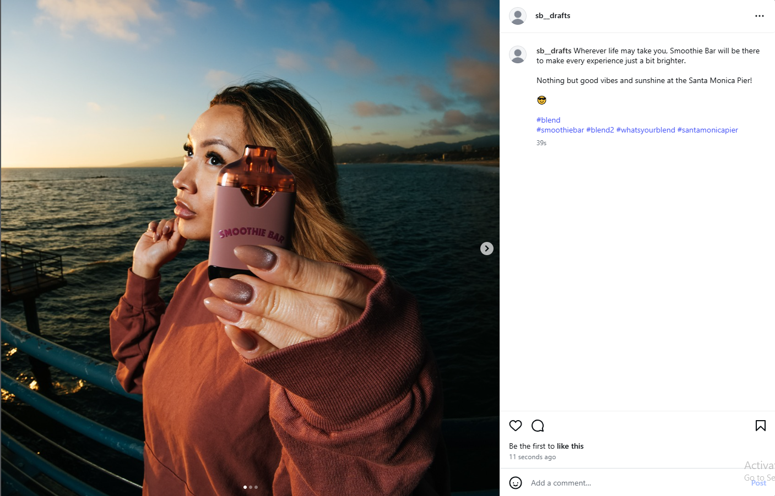
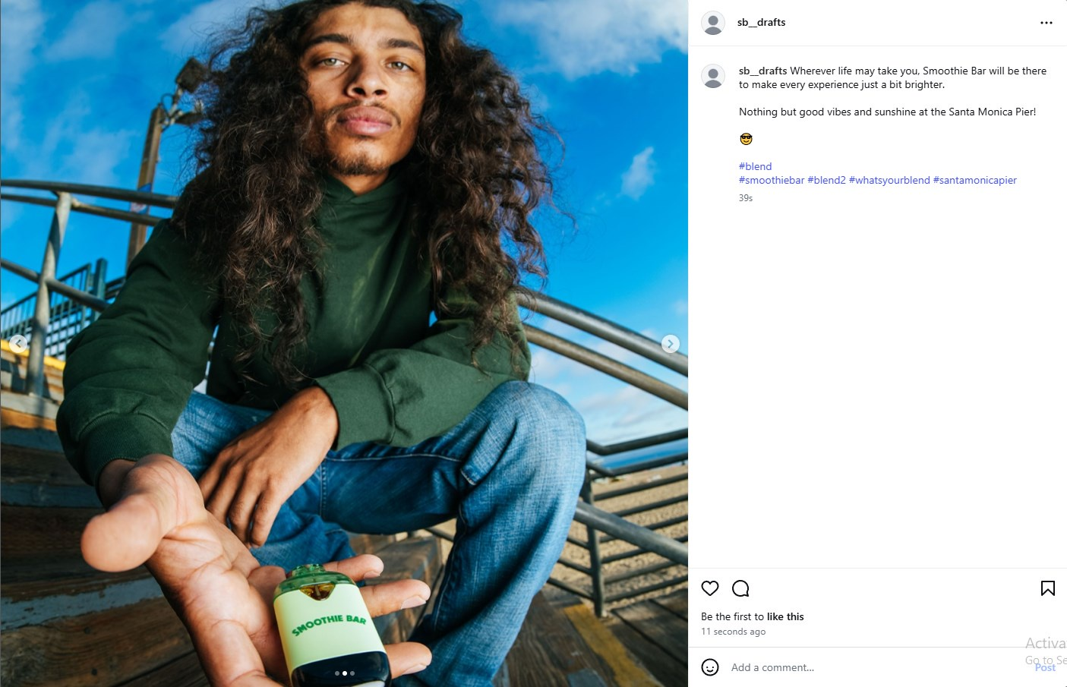
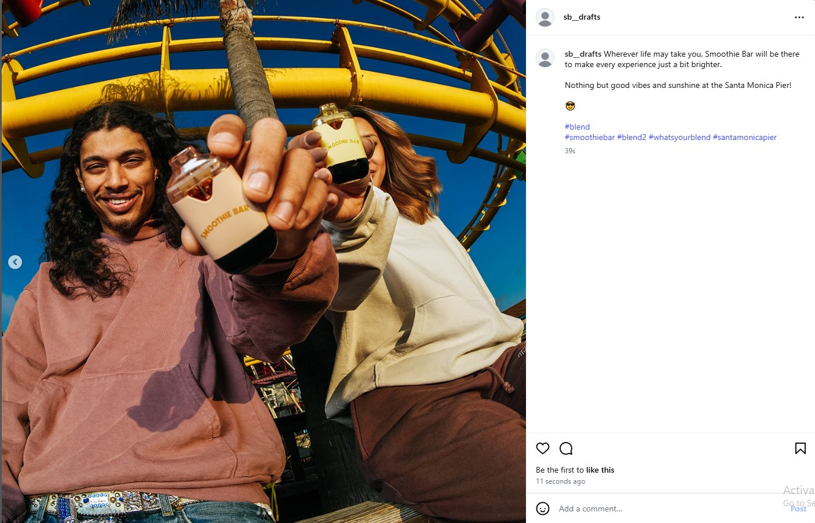

- Title: Santa Monica Pier Batch 2
Caption: We don't pass judgement, just the vape. 💯
Hashtags: #blend #smoothiebar #blend2 #whatsyourblend #santamonicapier
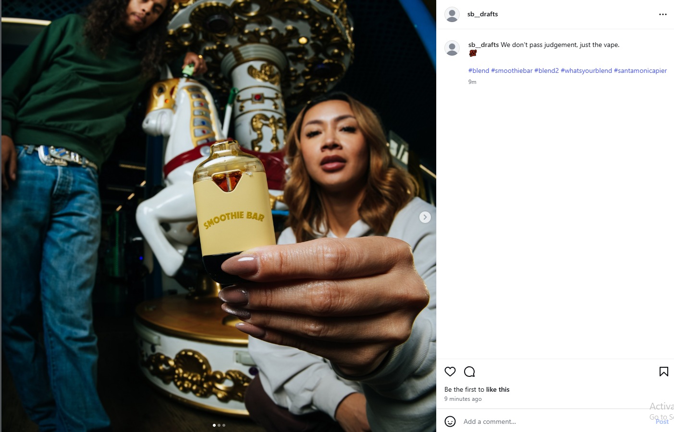
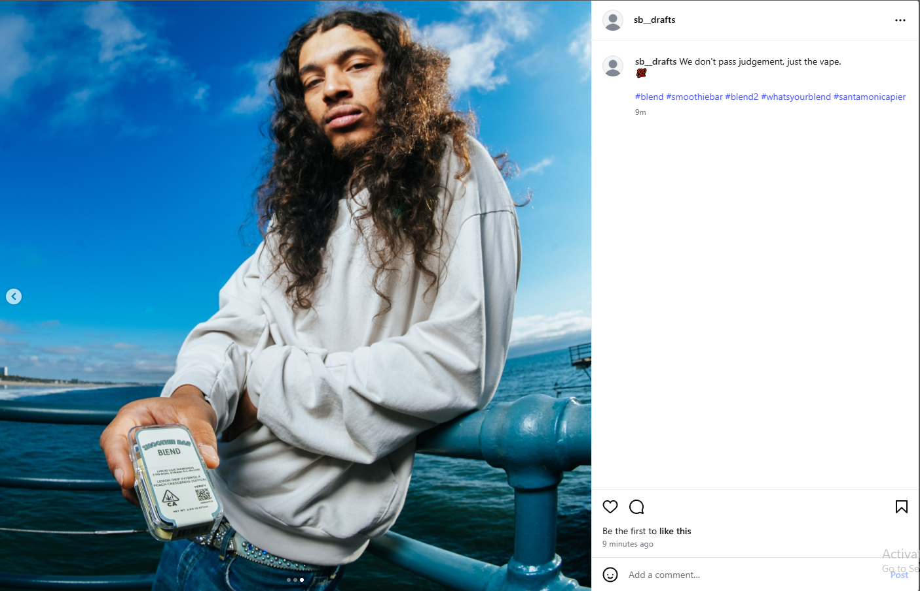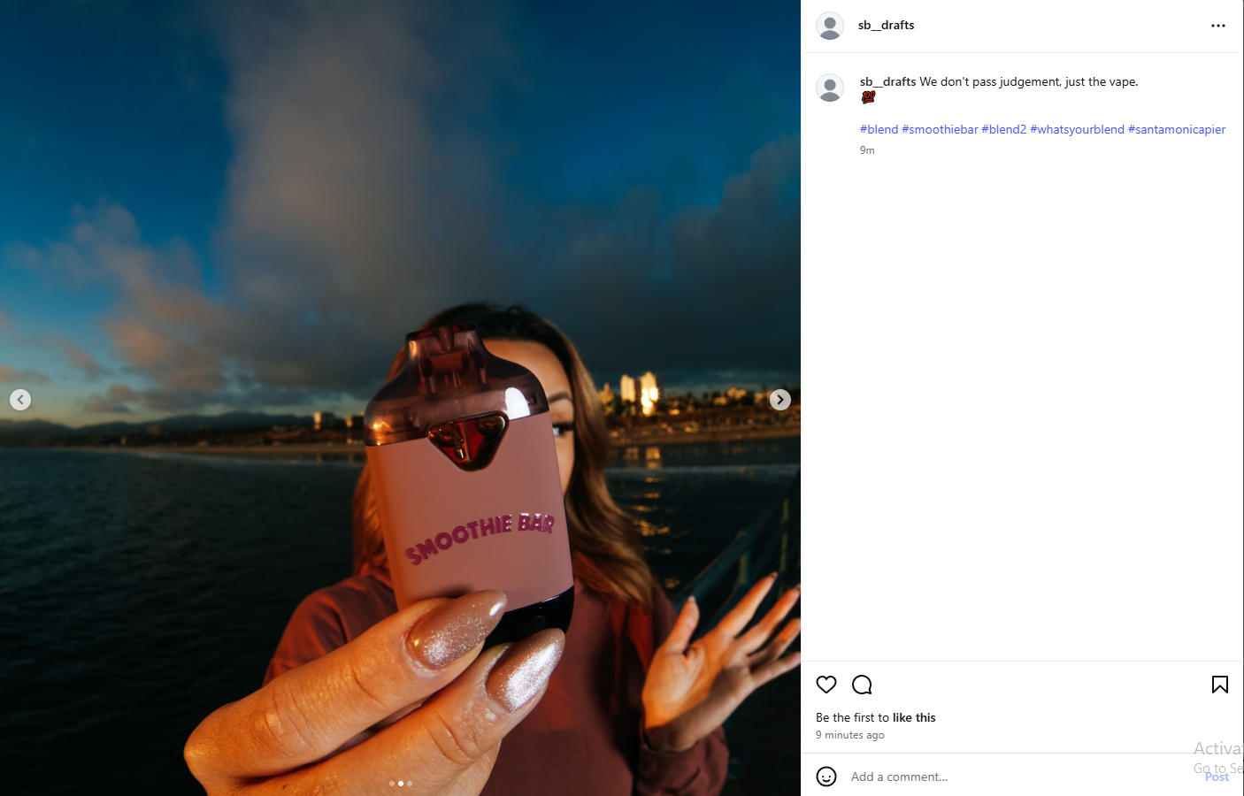

- Title: Santa Monica Pier Batch 3
Caption: The sight of ocean waves, the sound of seagulls, and the taste of Smoothie Bar Blend. That's our idea of paradise! 👌 🌊🎡🌊
Hashtags: #blend #smoothiebar #blend2 #whatsyourblend #santamonicapier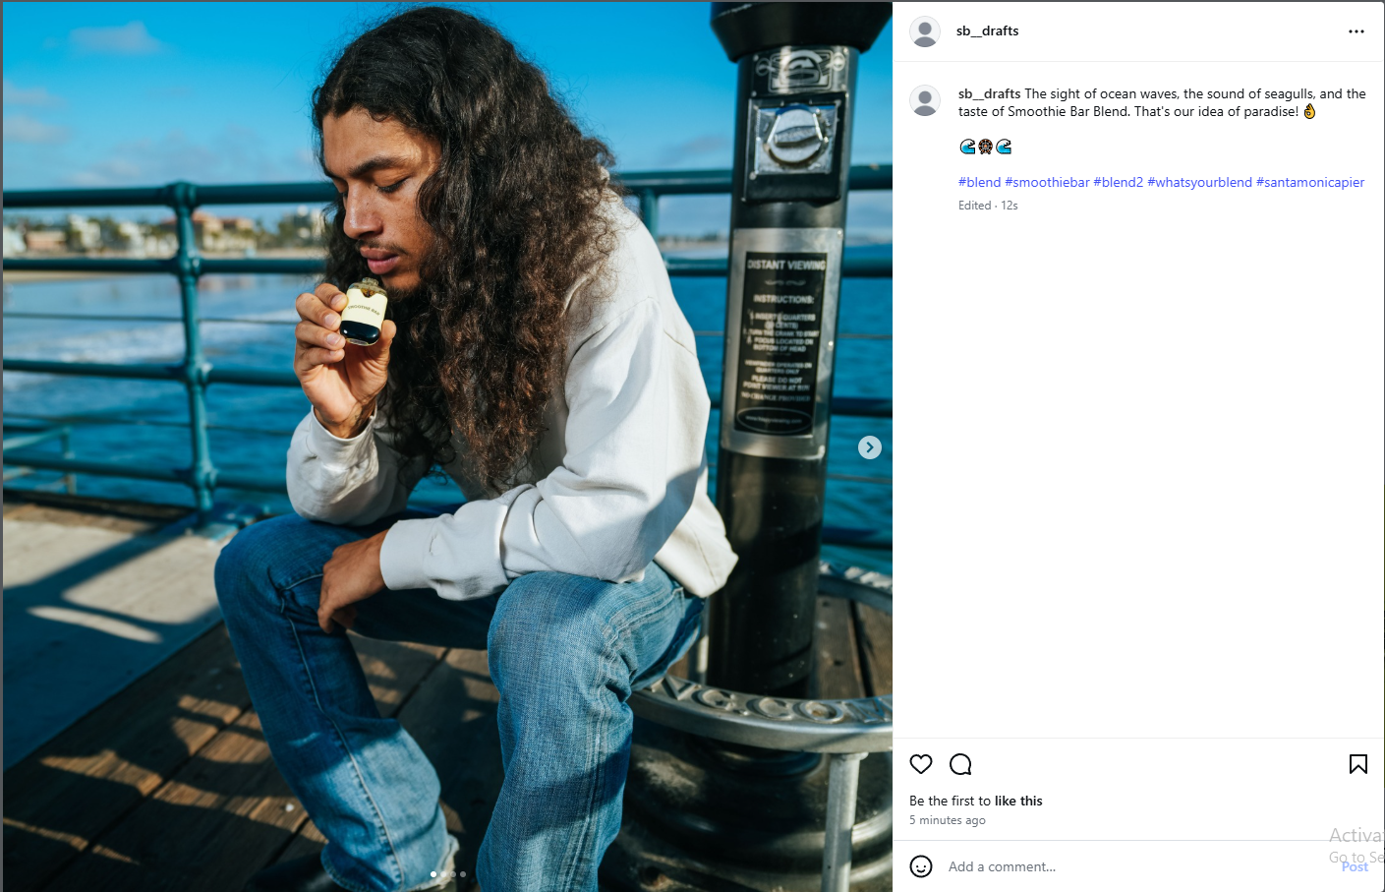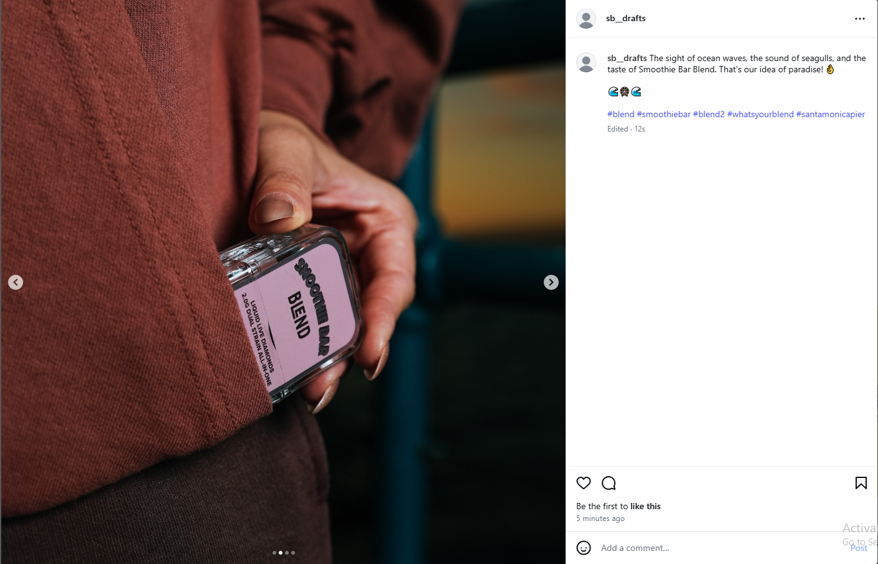
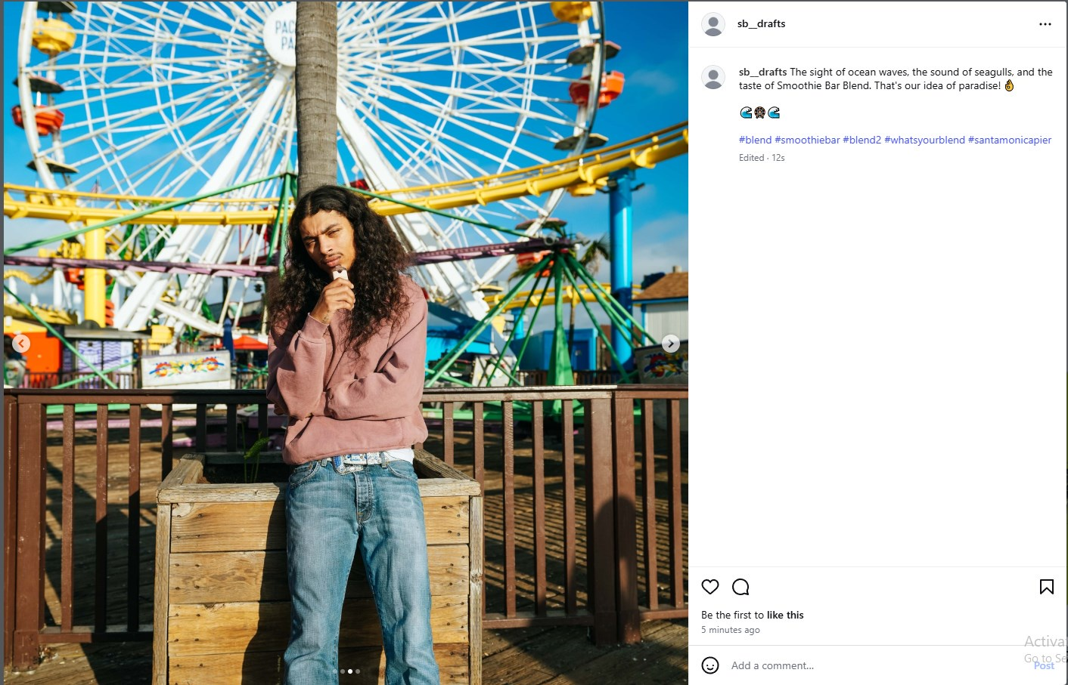
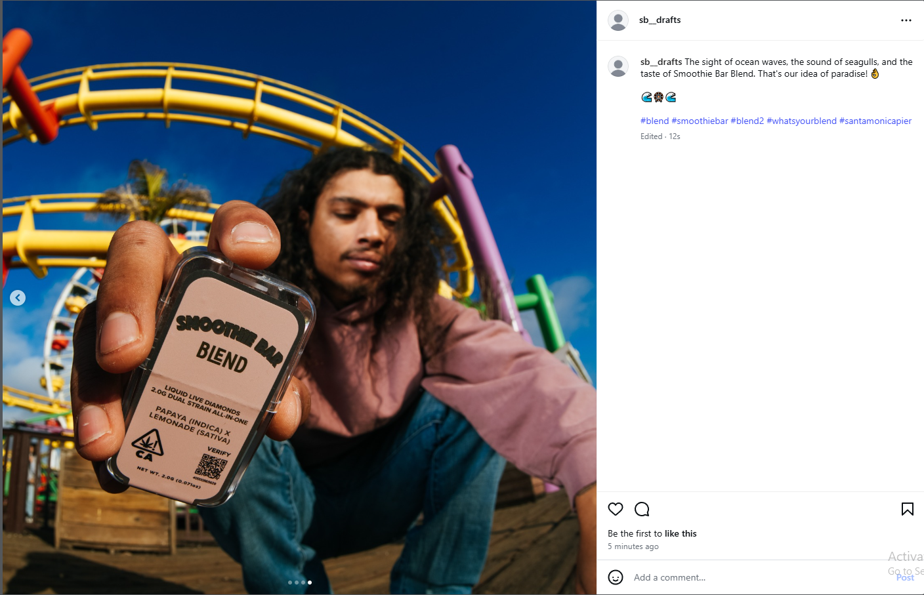
Reels
- Title:
Caption:
Embed Reel
Highlights
- Title:
Description:
Highlight cover image

Stories Schedule
- Stories Table - Title/Post Date/Time/Link to Post Below/Notes/Interactive elements

Title | Post Date | Time | Link | Notes | Interaction
Educational | 12/13 | 8:00am |  | Safety/tutorial | Users will know their safety is considered
Behind Scenes | 12/14 | 8:00am |  | How it’s made | User is interested in process
Shoutout | 12/15 | 8:00am |  | Partners/workers | Exposed to product
Product Demo | 12/16 | 8:00am |  | Showcase | User sees device in action
Poll | 12/17 | 8:00am |  | Product or variant pref | User votes
Fun Facts | 12/18 | 8:00am |  | Lesser known facts | User learns unique info
Q&A | 12/19 | 8:00am |  | Answer questions live | User asks and shows knowledge
Customer Spotlight | 12/20 | 8:00am |  | Customer w/ product | Exposed to product
Lifestyle | 12/21 | 8:00am |  | Day in the life, laid back | Gives user vibe, relatable
Testimonial/UGC | 12/22 | 8:00am |  | Feedback | User hearing from other

- Collage of stories photos to be used - vids to be used linked/embedded in doc

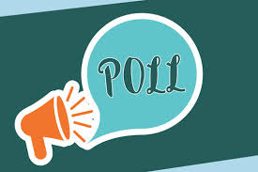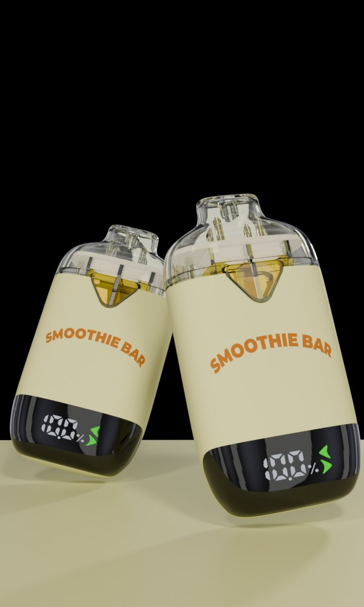

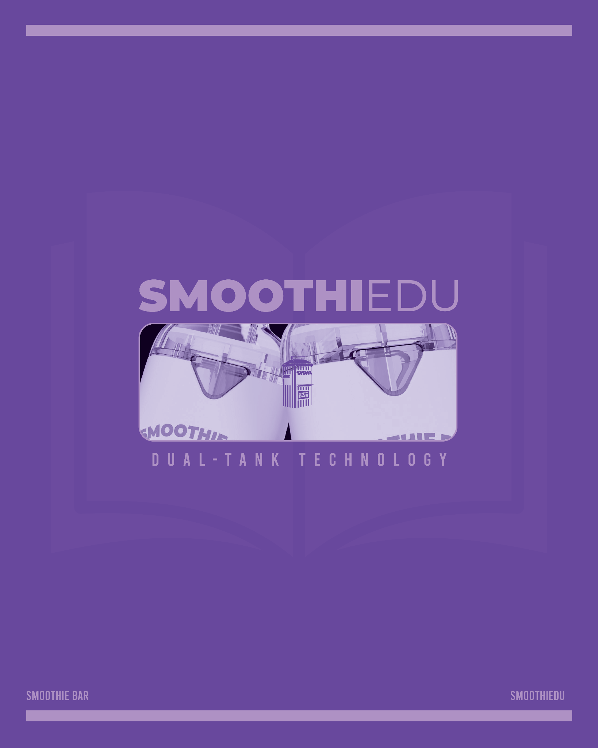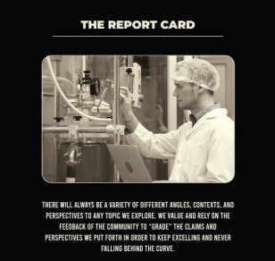

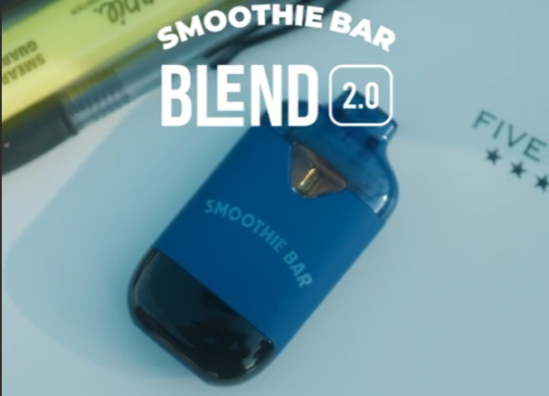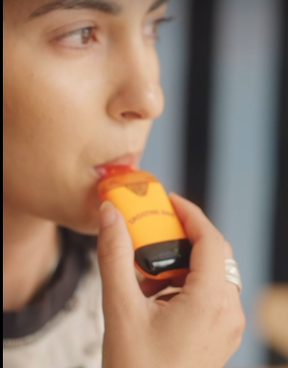

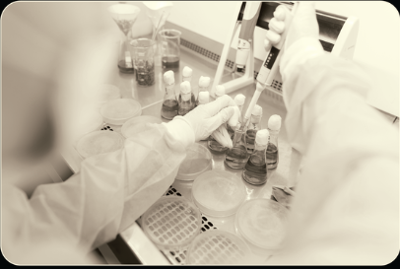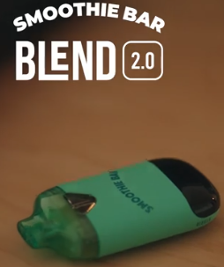

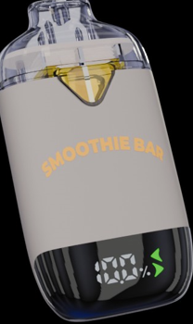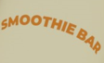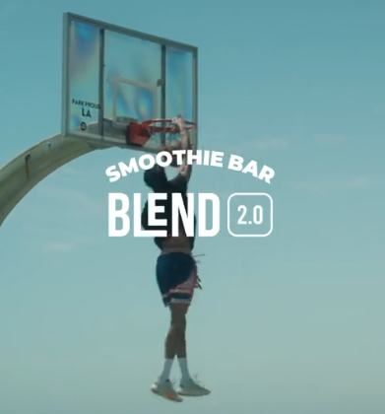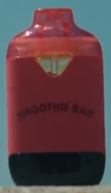

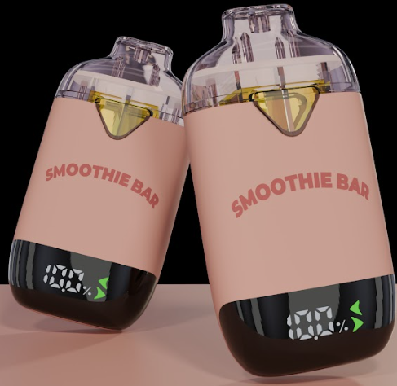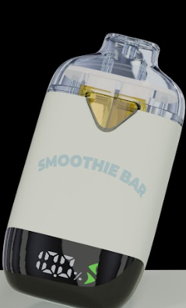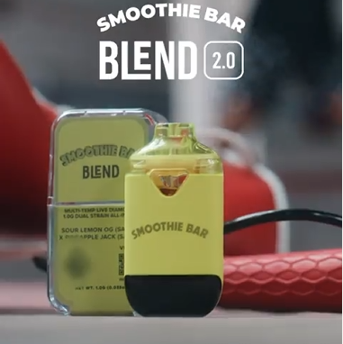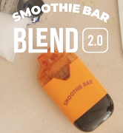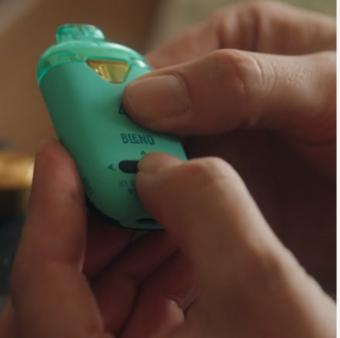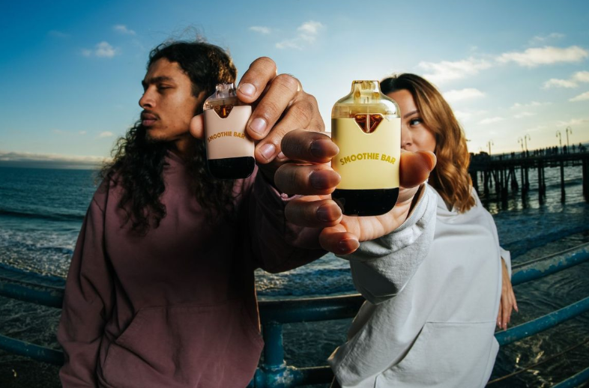

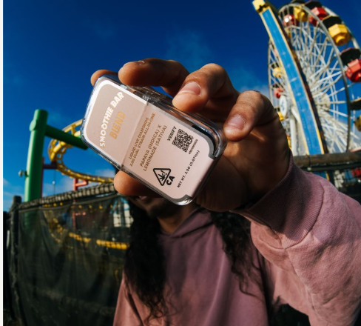
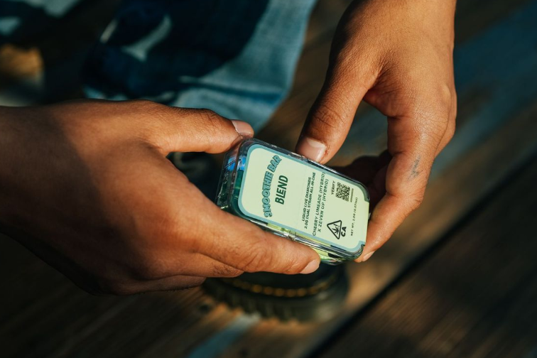

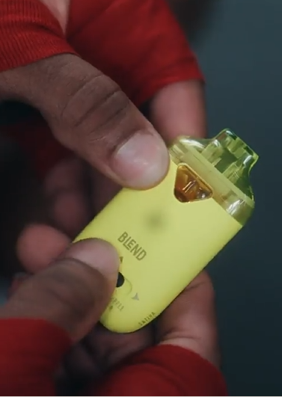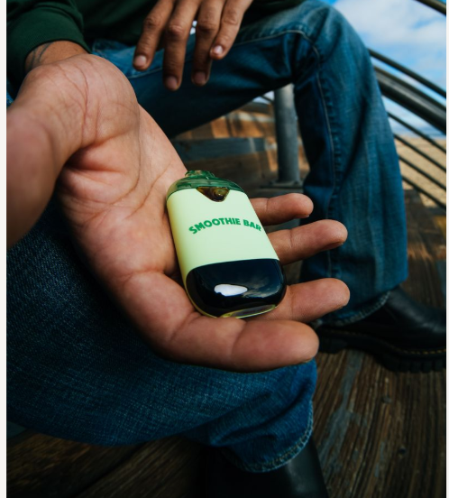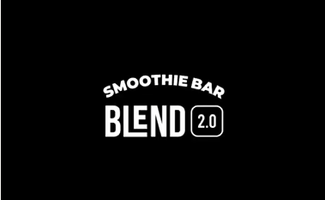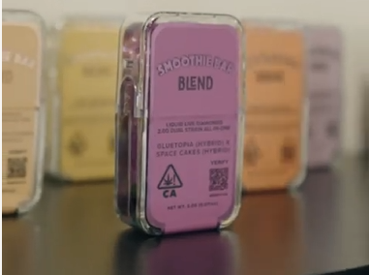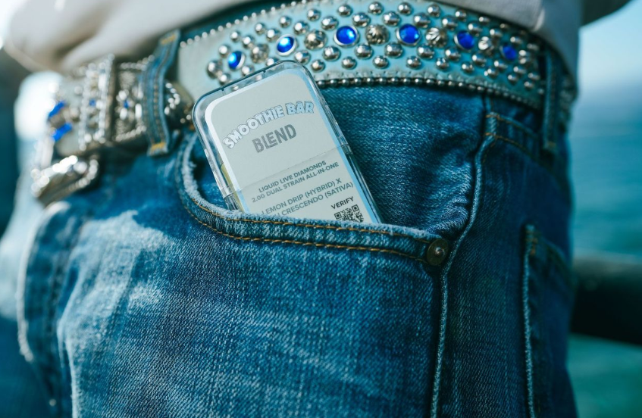

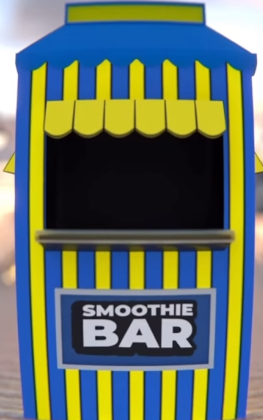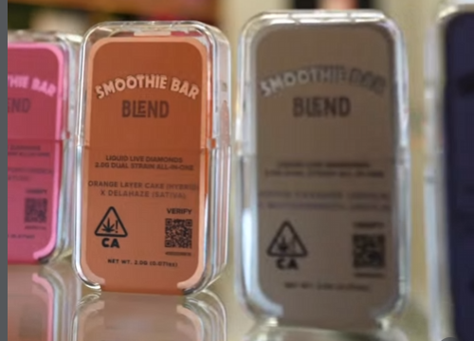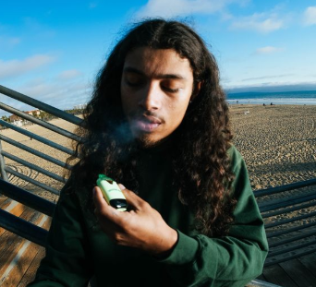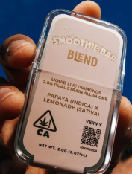

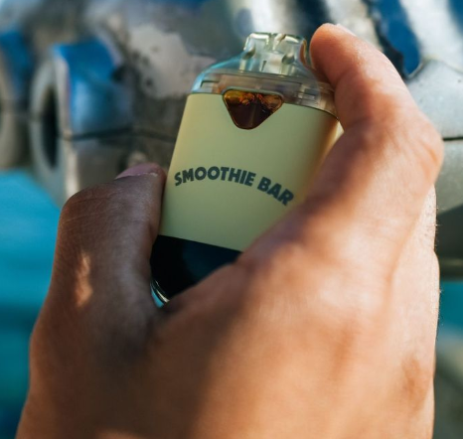

*Embed Links*

Account Interaction
- Master list of accounts to interact with, amount of interactions planned per day, types of interactions (comments/likes, etc), easy way to “mark off” when interaction for the day has been completed (checklist?)

Account Name | Interaction Type | Planned per day | Last Interaction | Completed?

